# Python自动化运维开发基础

## 前言

Python是一门解释型语言，主要应用于WEB开发、大数据分析、爬虫、人工智能、自动化运维开发等领域。

## 第一章 Python开发环境准备

学习目标：

1、了解python开发系统(centos7.5)部署

2、了解centos7.5系统默认python使用

3、掌握centos7.5系统ipython基本使用

4、掌握centos7.5系统pycharm基本使用

5、掌握centos7.5系统python多版本开发环境部署

### 一、Centos7.5系统部署

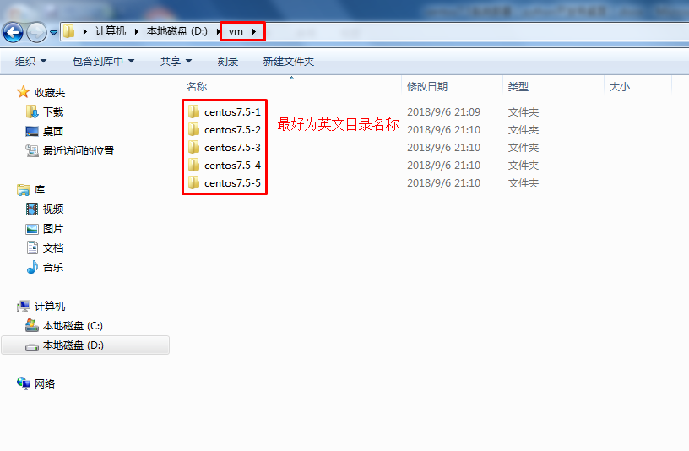

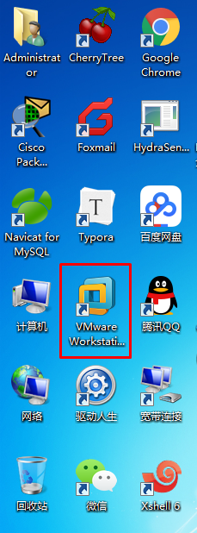

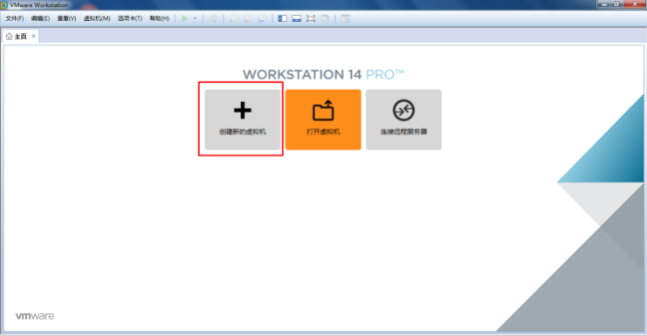

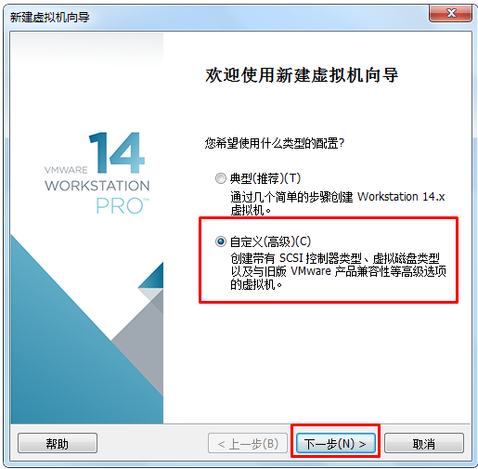

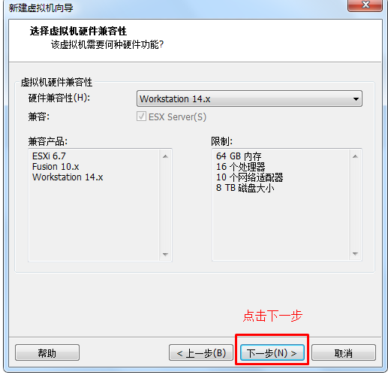

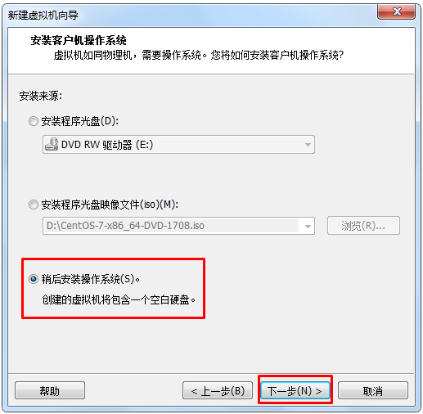

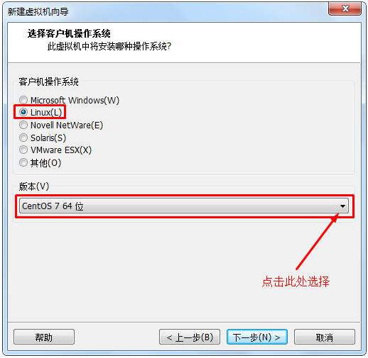

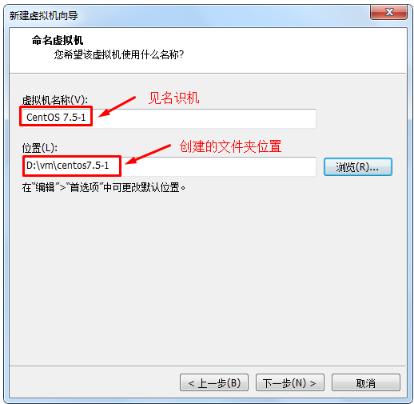

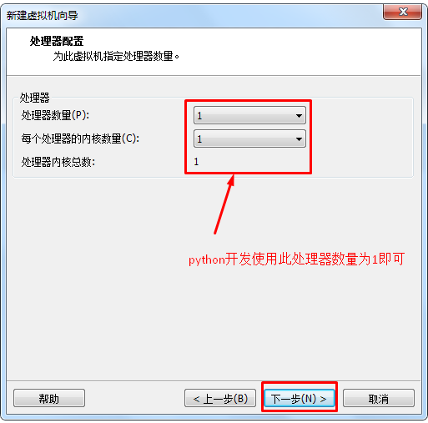

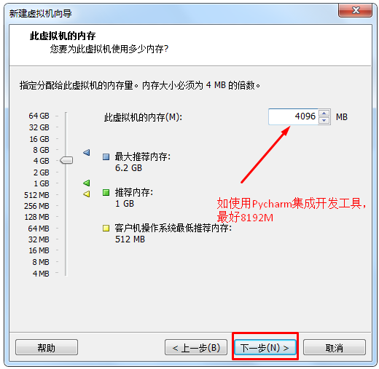

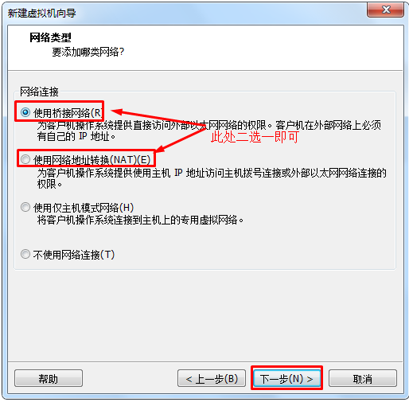

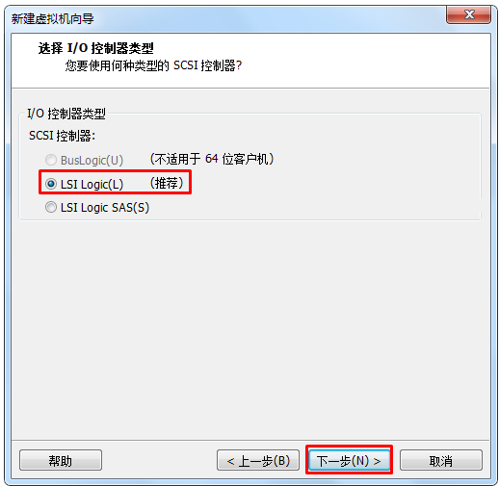

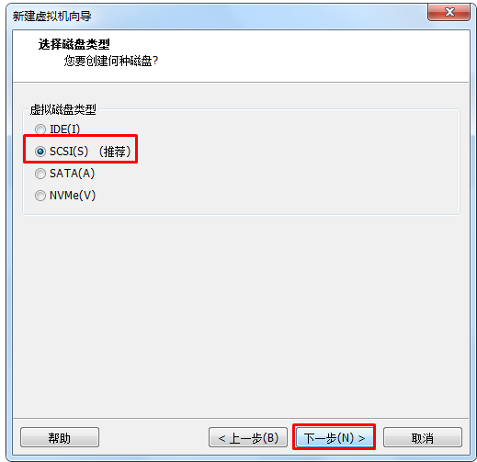

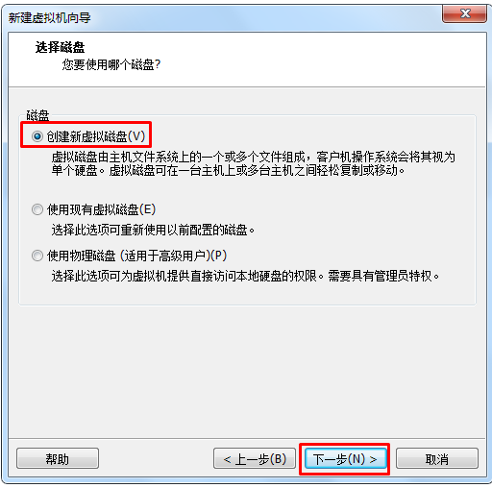

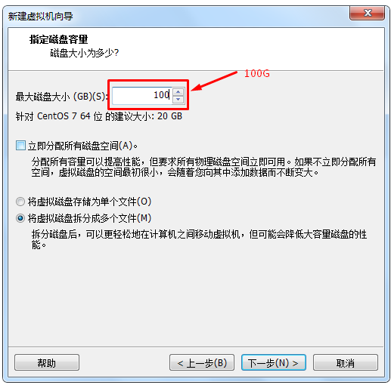

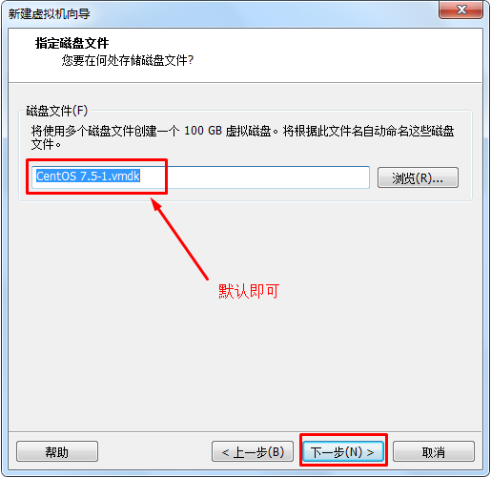

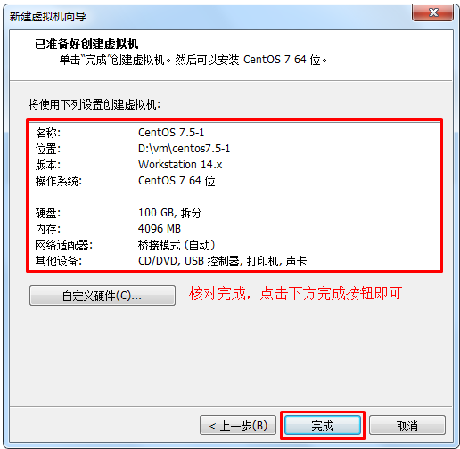

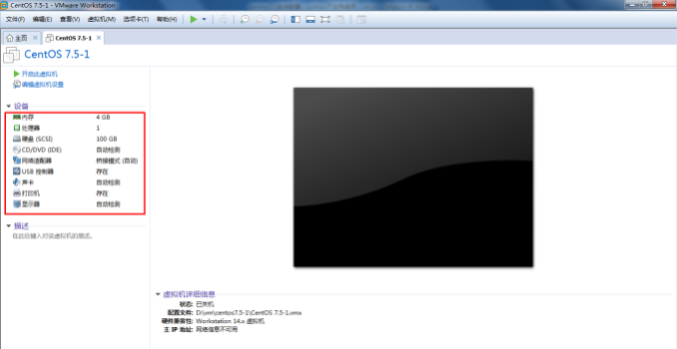

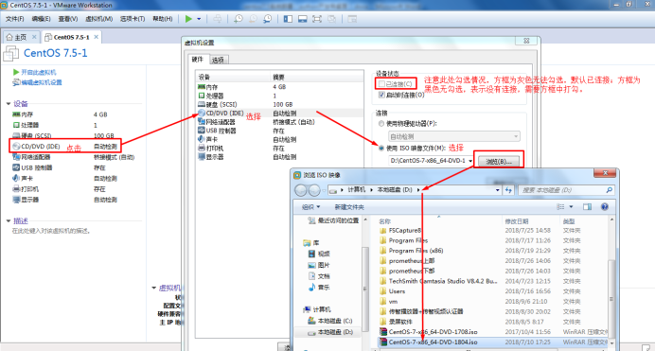

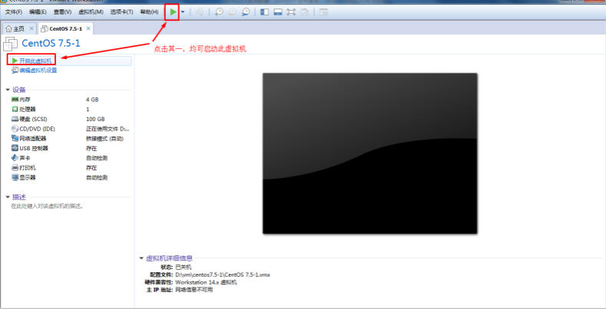

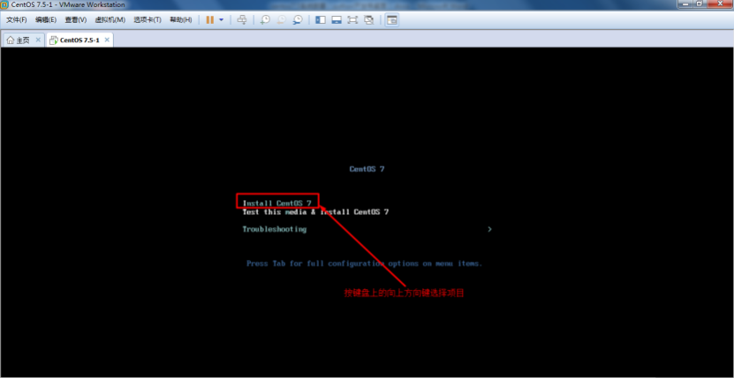

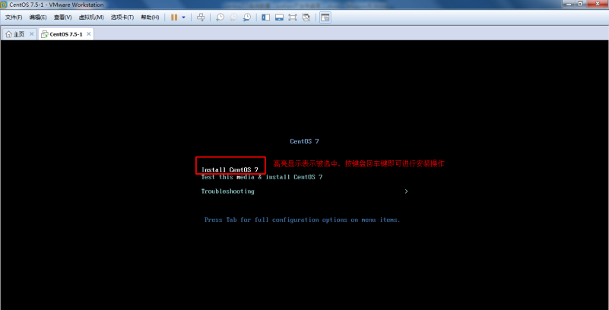

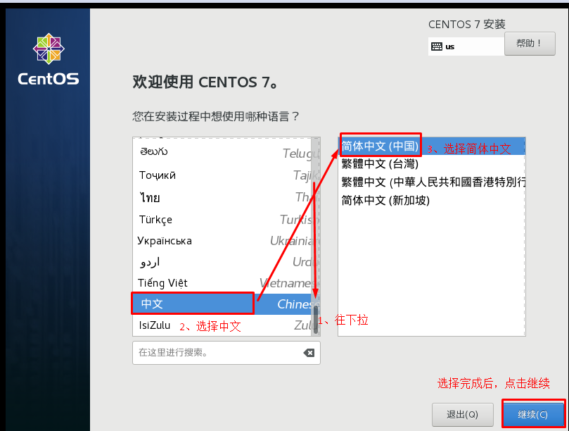

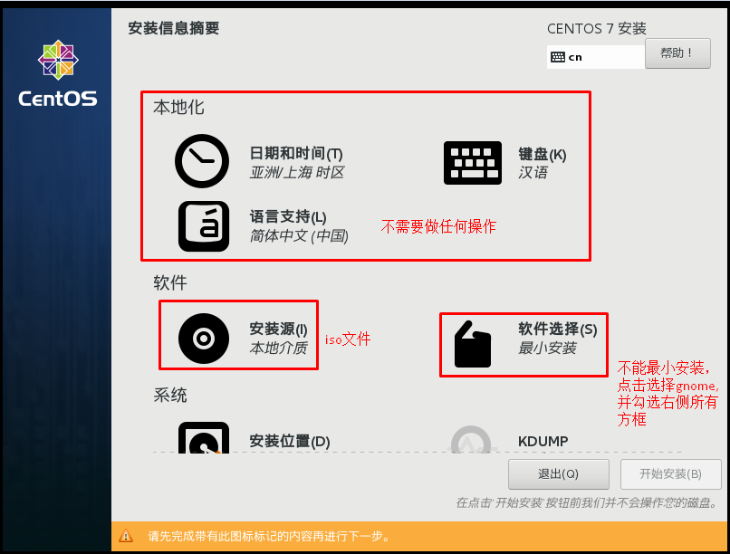

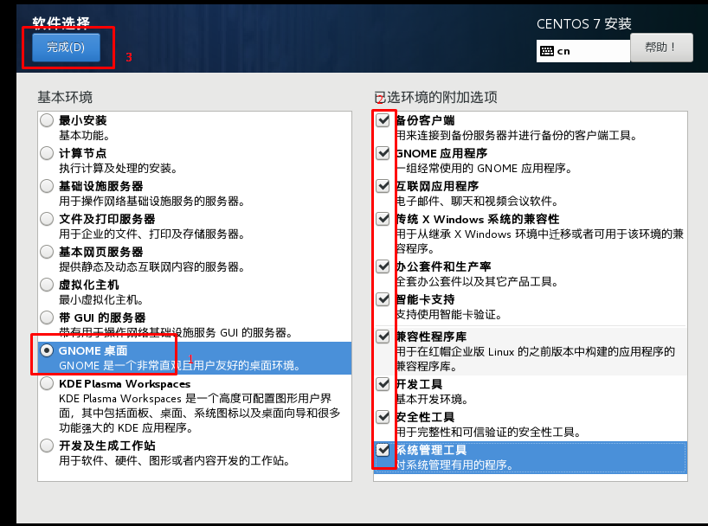

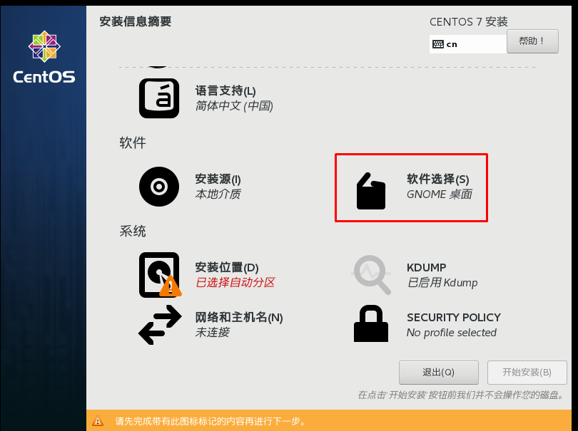

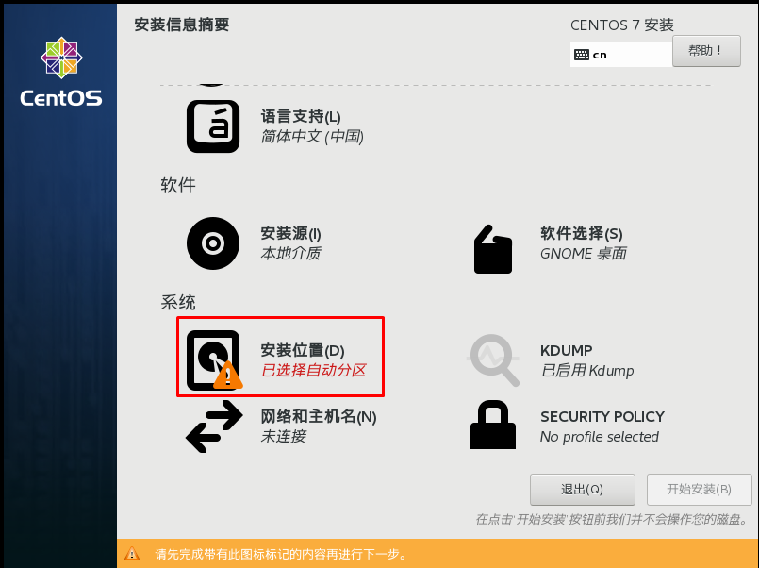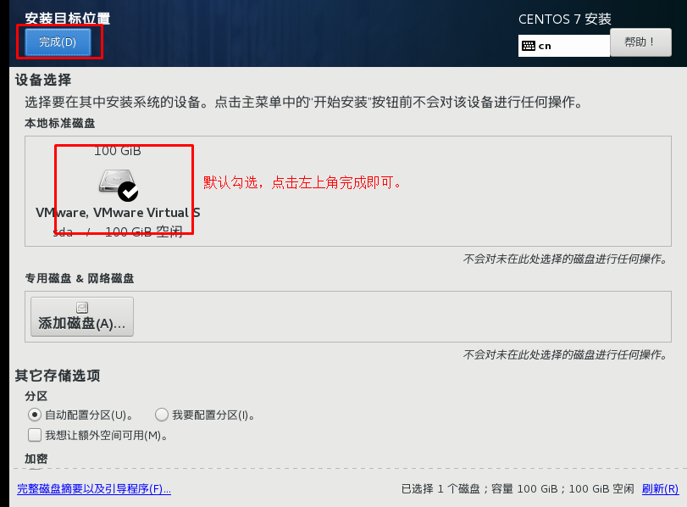

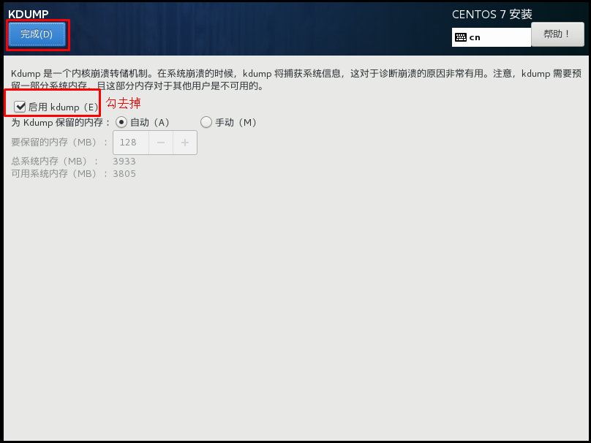

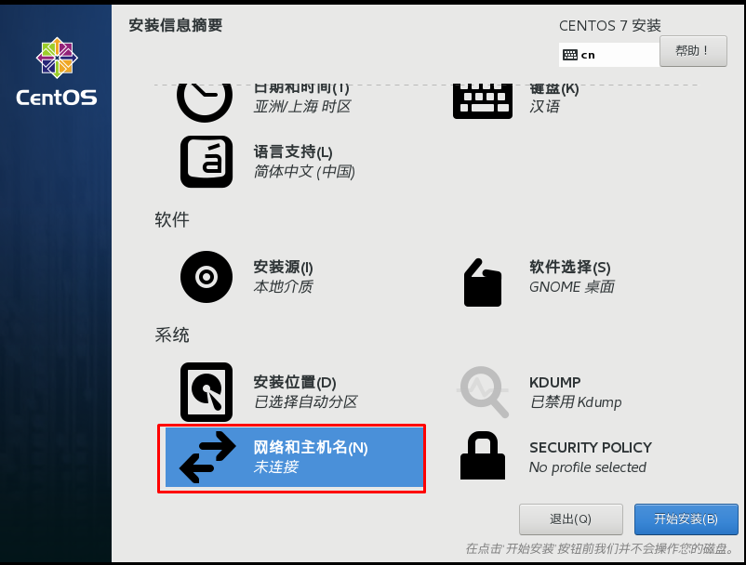

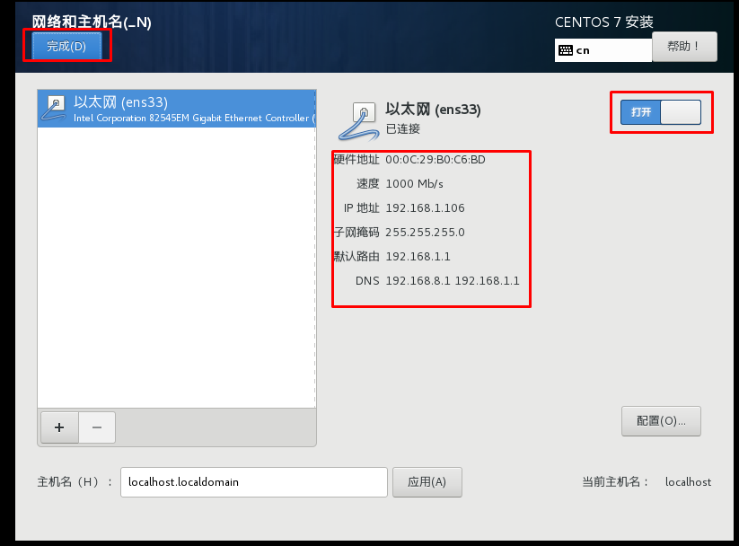

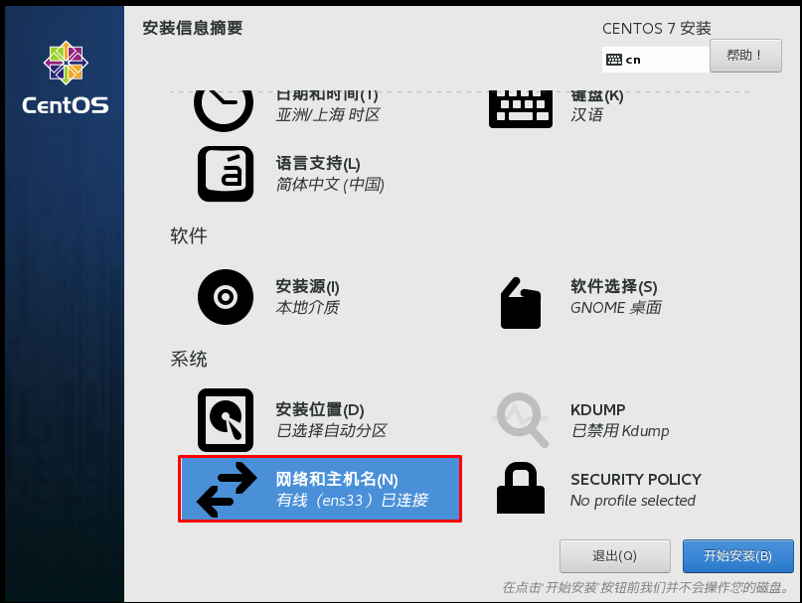

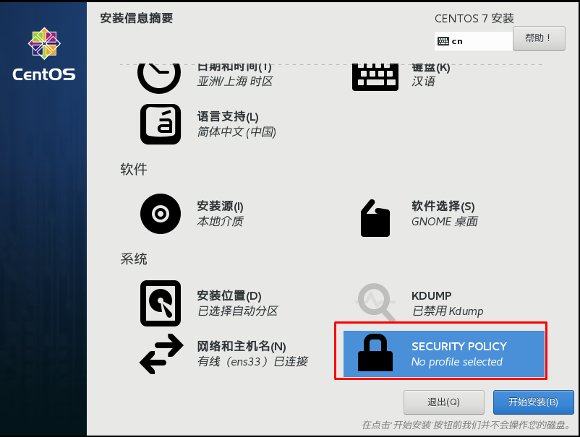

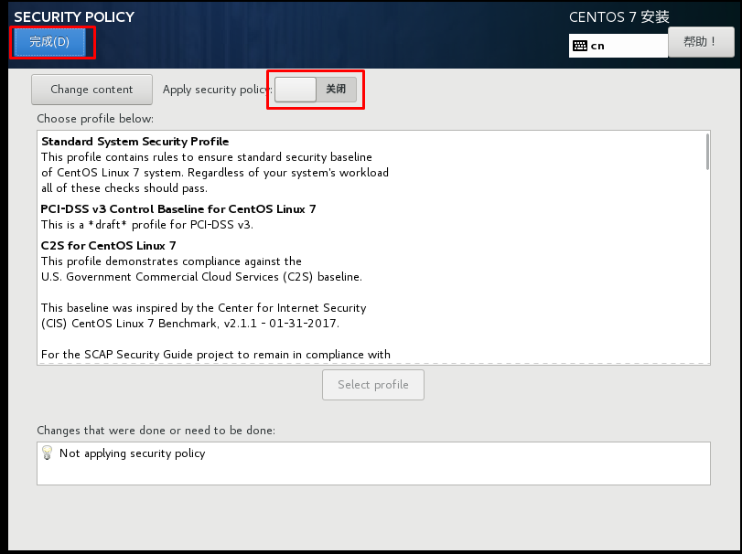

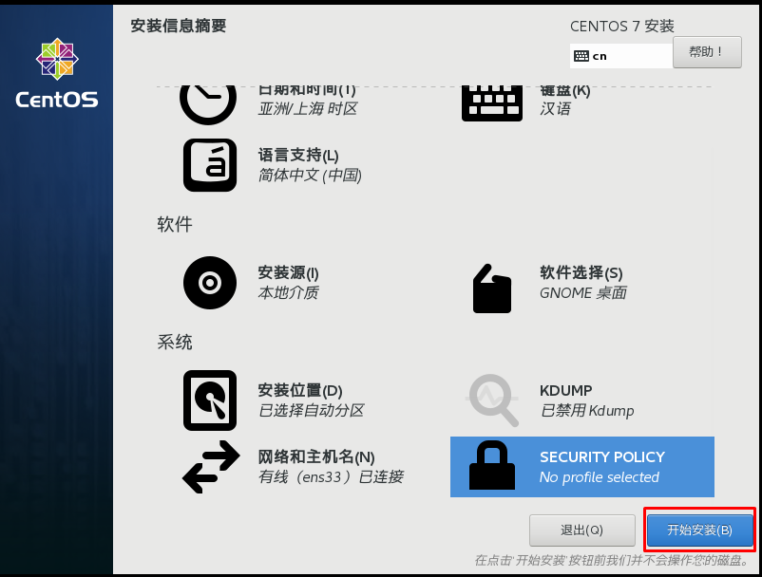

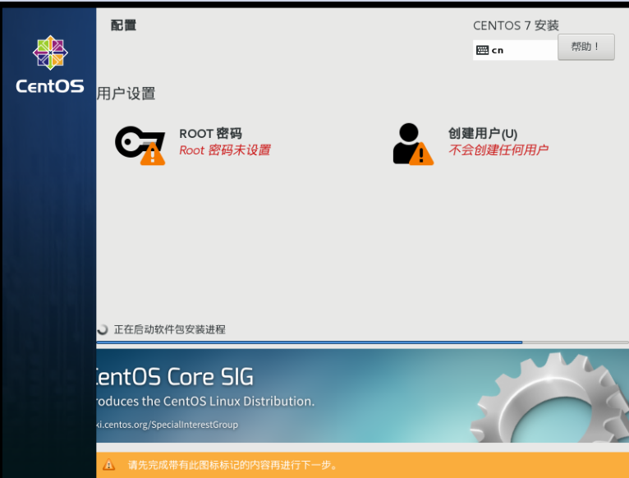

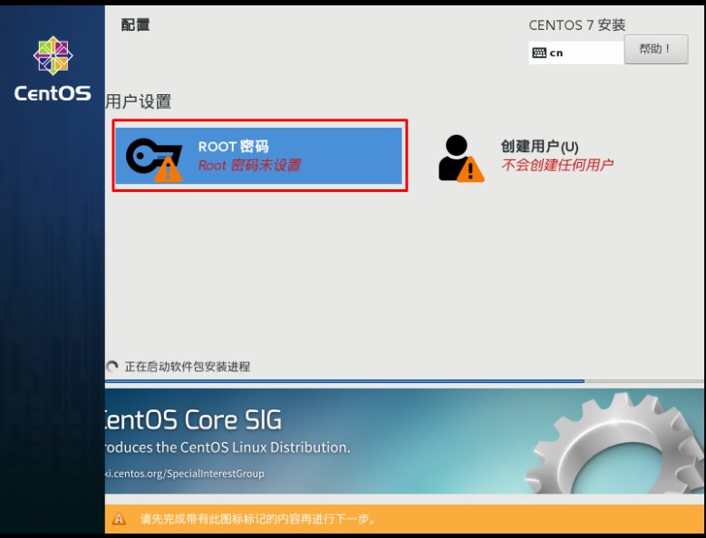

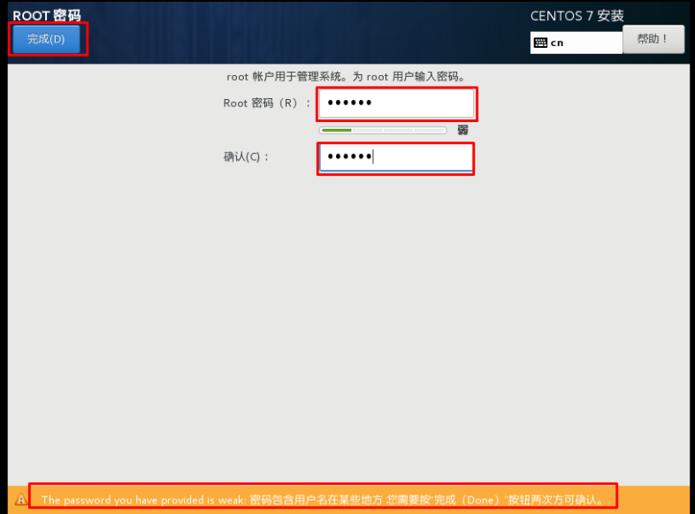

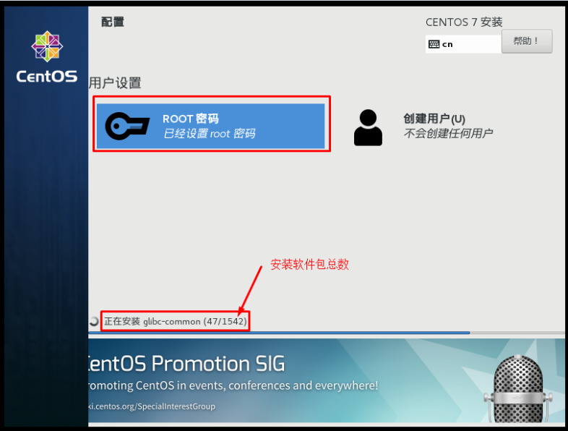

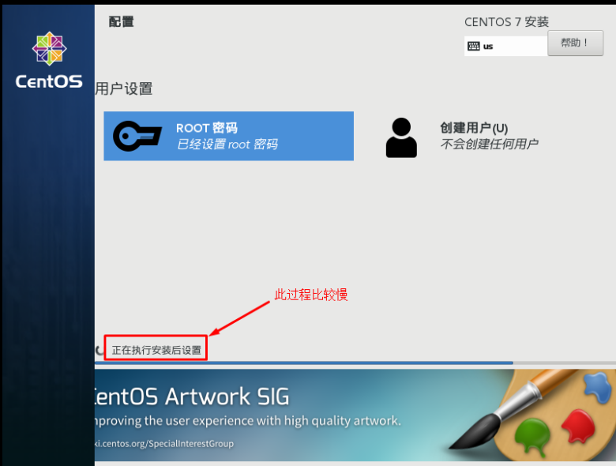

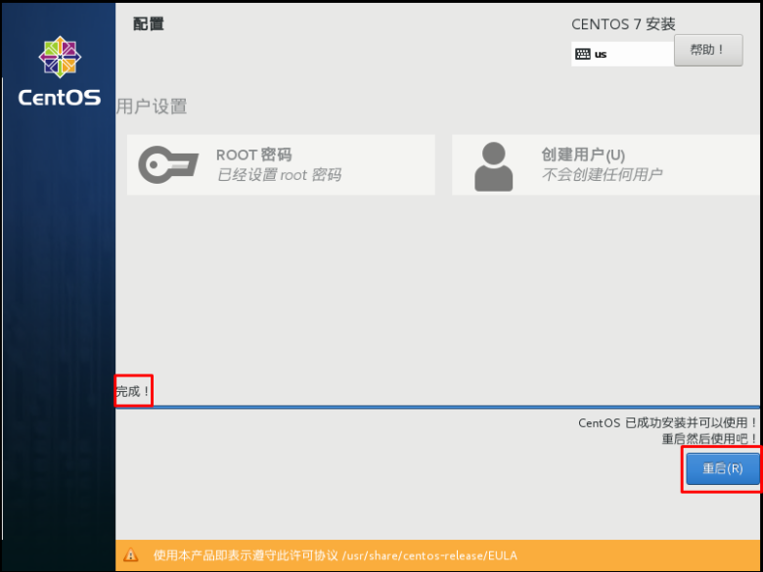

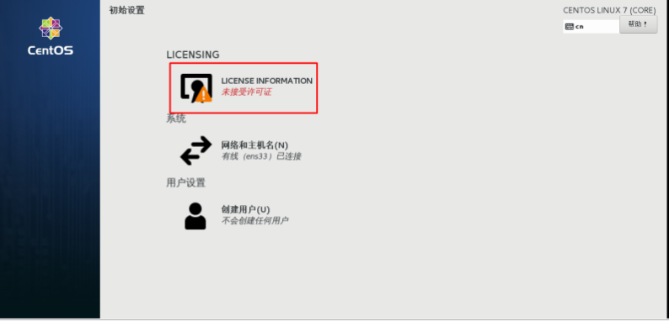

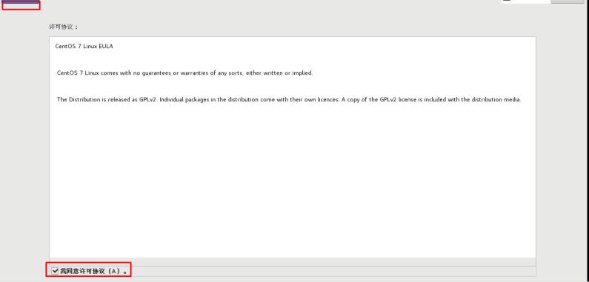

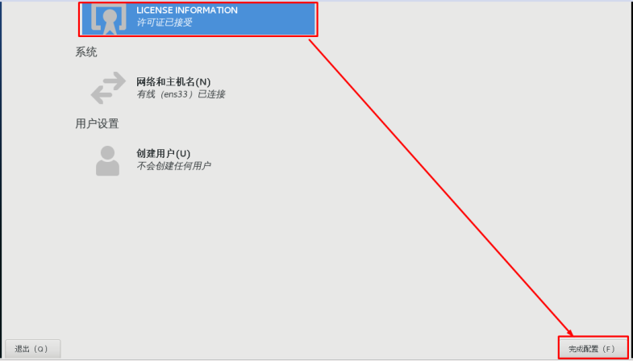

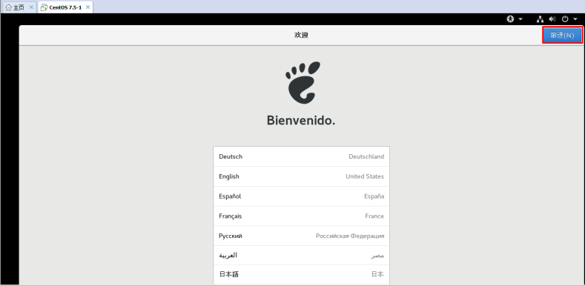

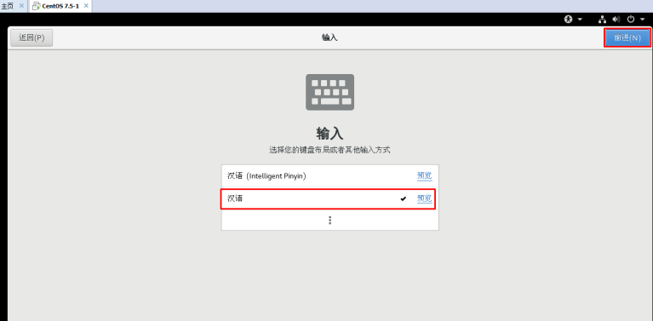

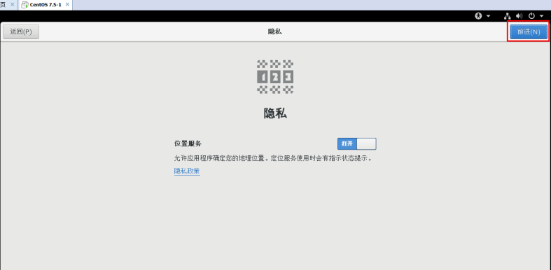

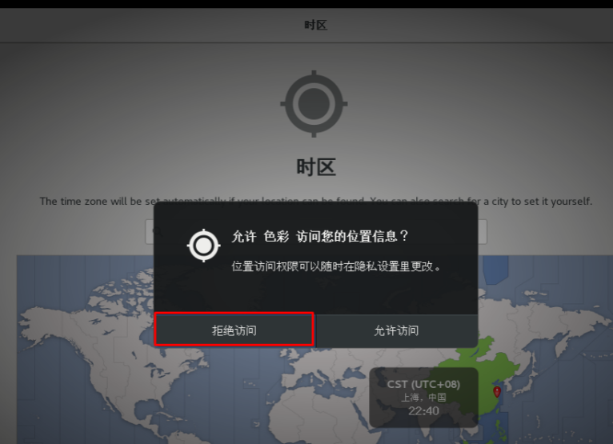

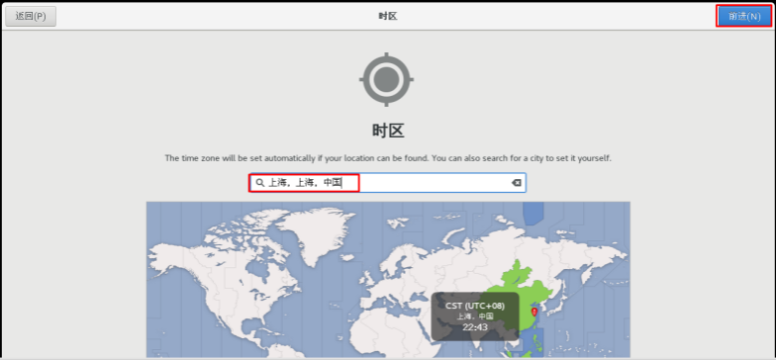

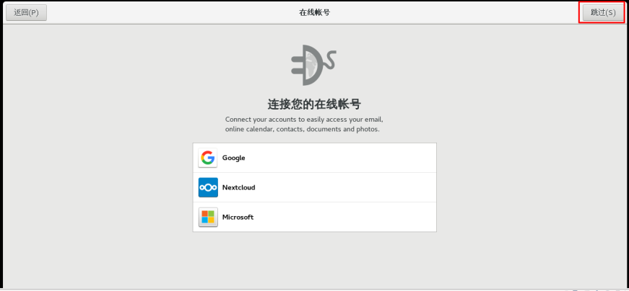

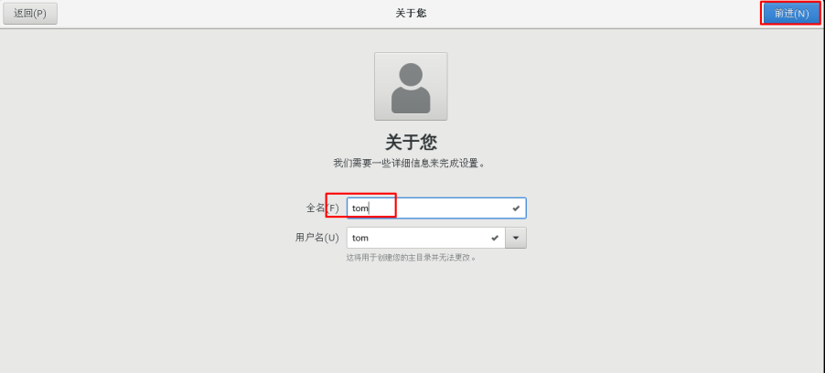

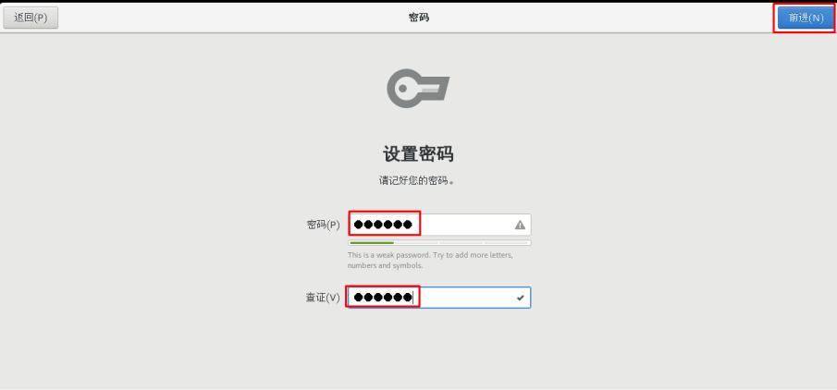

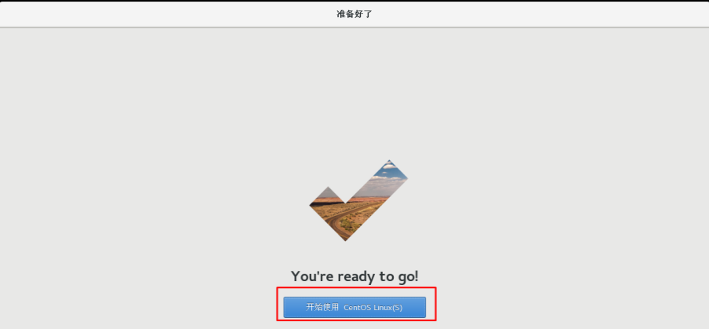

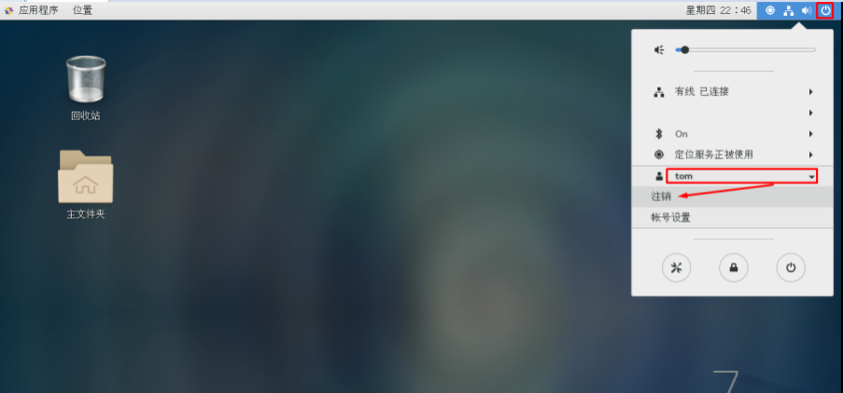

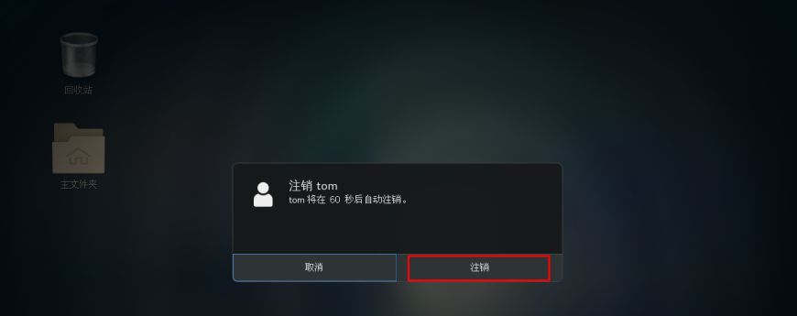

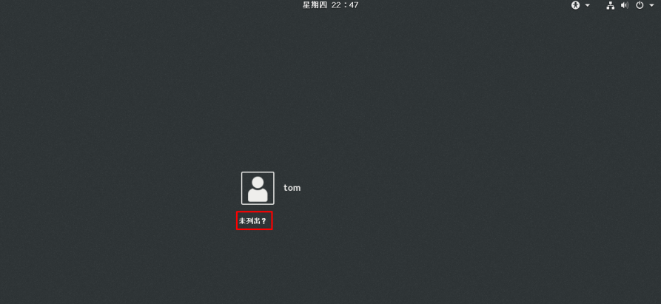

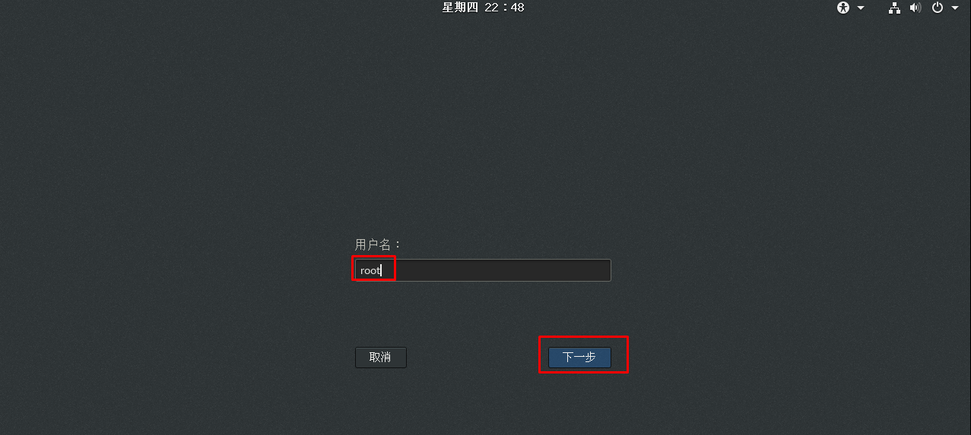

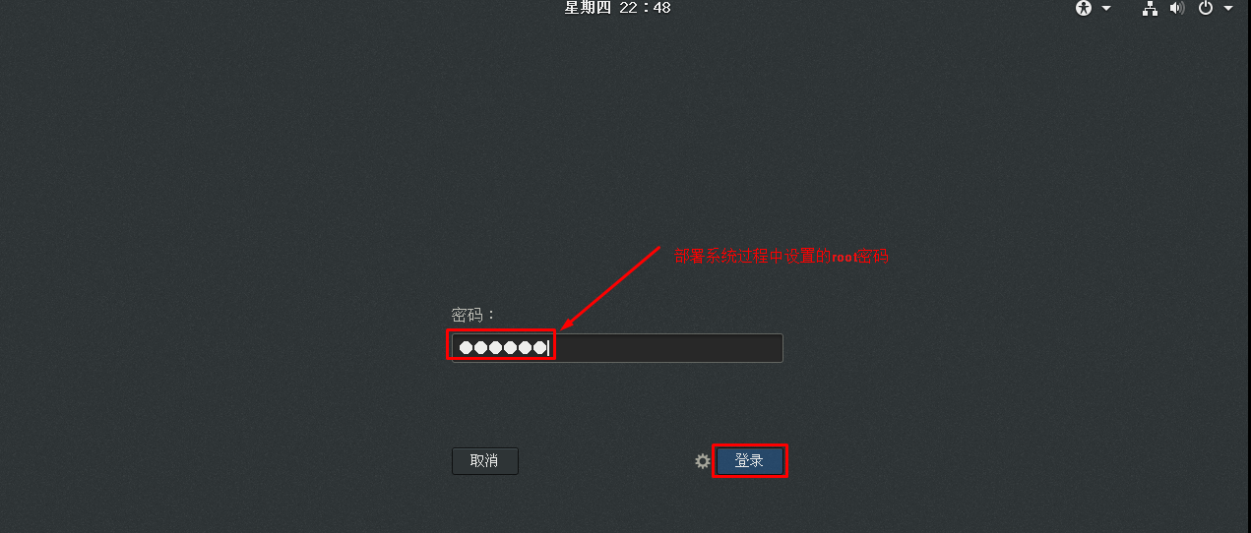

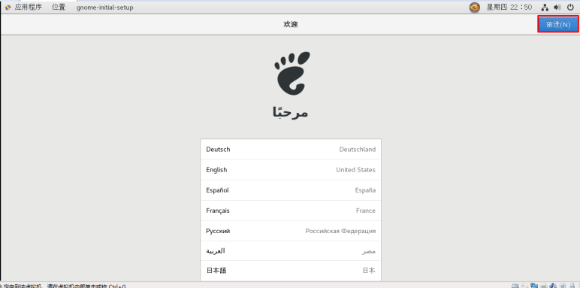

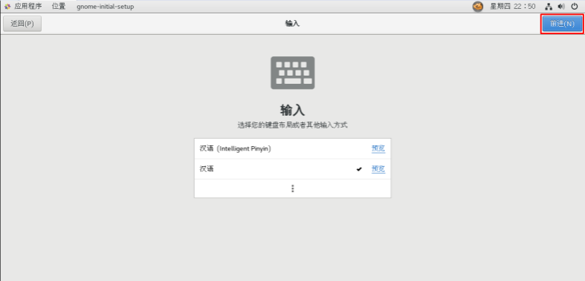

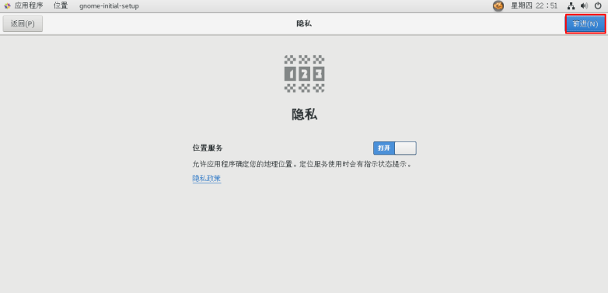

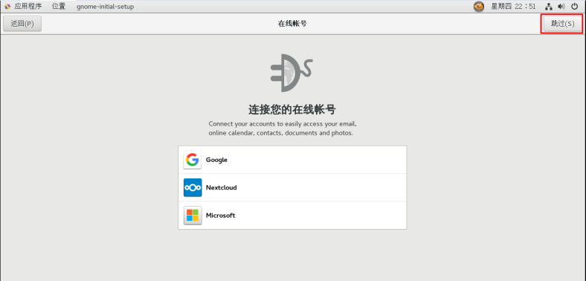

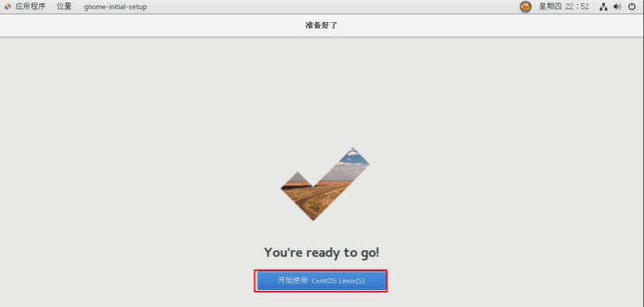

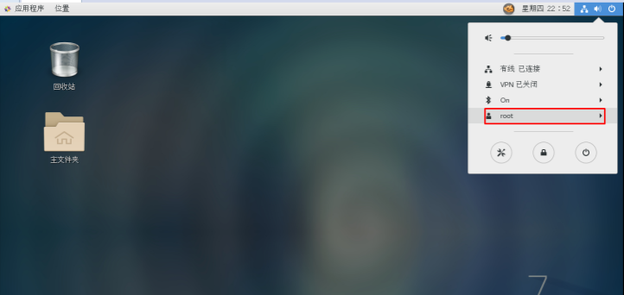

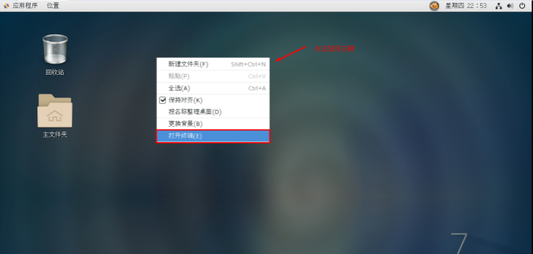

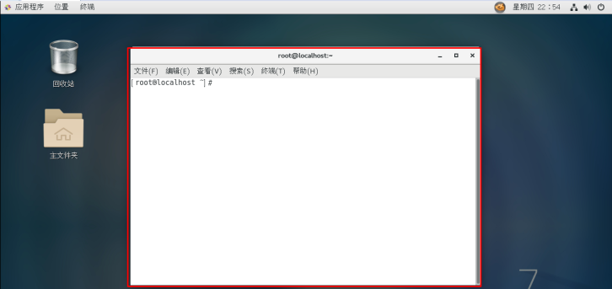

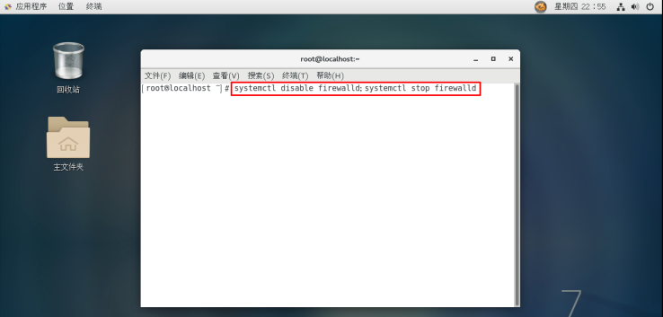

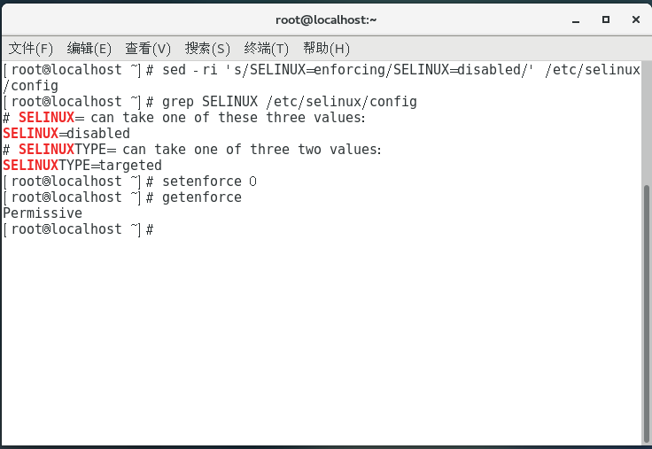

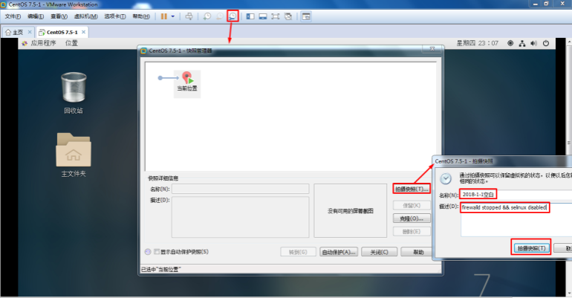

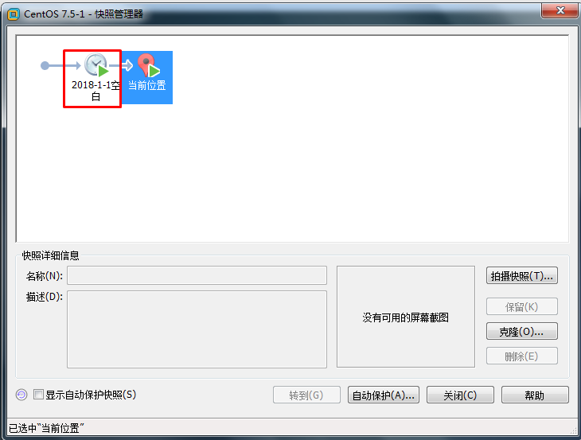

### 二、Centos7.5系统默认Python使用

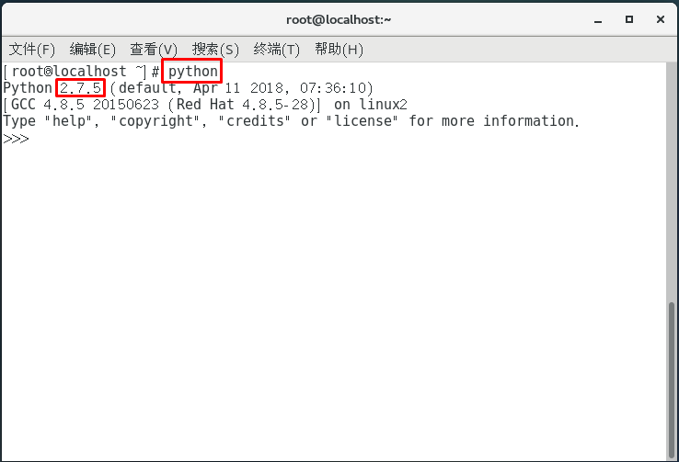

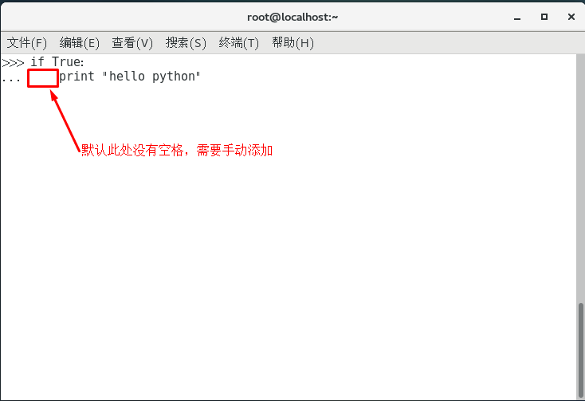

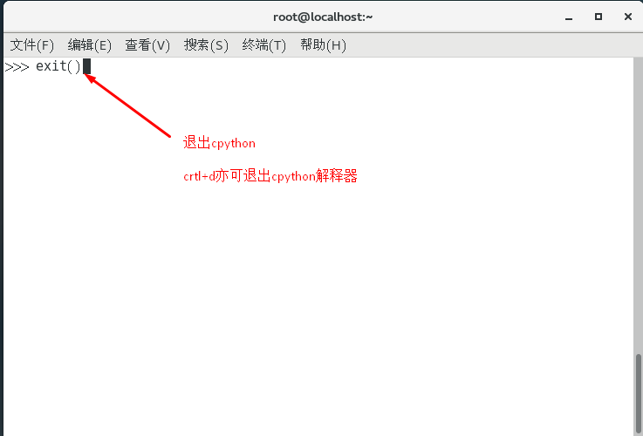

### 三、Centos7.5系统ipython部署及应用

1、pip工具安装环境准备

**[**root**@**localhost **~]**# yum **-**y install epel-release

**[**root**@**localhost **~]**# yum **-**y install python-devel

2、pip工具安装及升级

**[**root**@**localhost **~]**# yu **-**y install python2-pip

**[**root**@**localhost **~]**# pip install **--**upgrade pip

**[**root**@**localhost **~]**# pip list

3、使用pip工具安装ipython

**[**root**@**localhost **~]**# pip install ipython

4、ipython使用

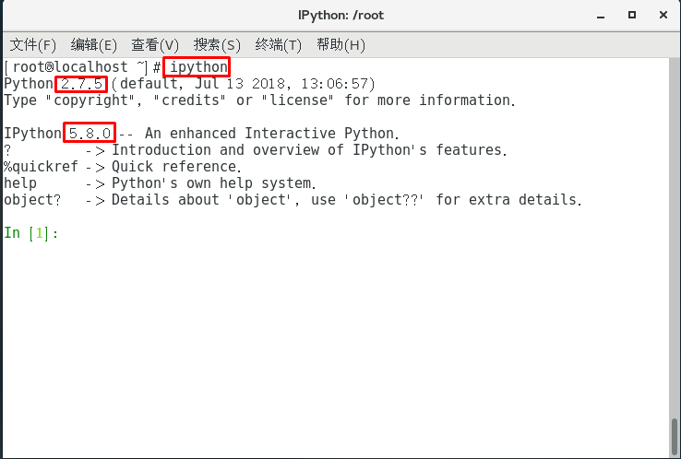

### 四、Centos7.5系统Pycharm安装及使用

1、pycharm工具介绍

为python开发常用的集成开发工具，以提高程序员开发速度。

2、pycharm下载（http://www.jetbrains.com/pycharm/）

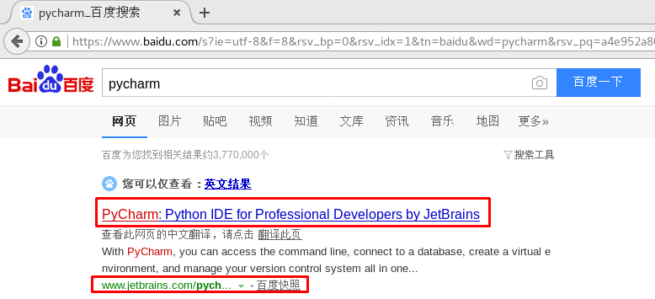

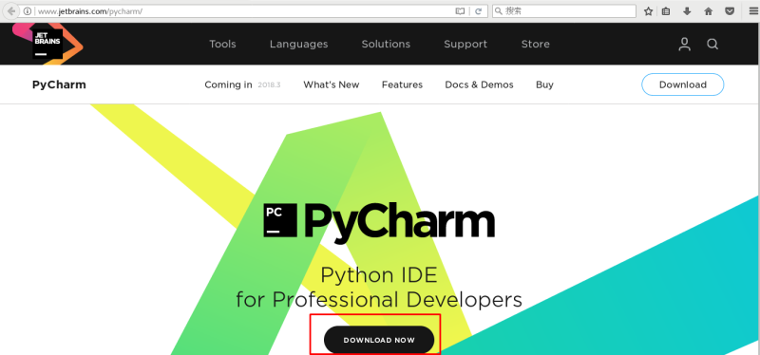

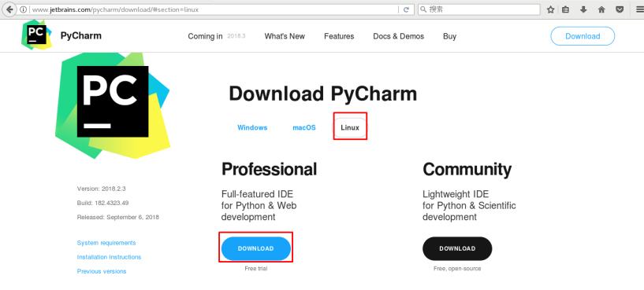

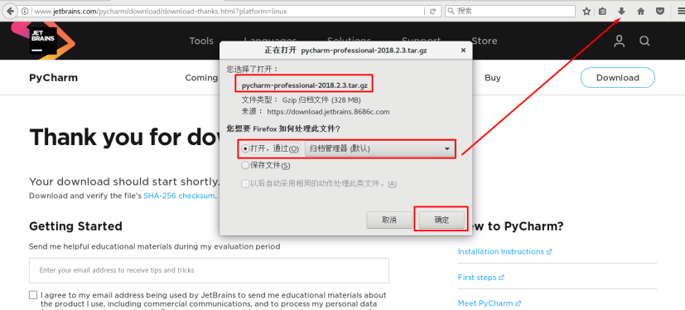

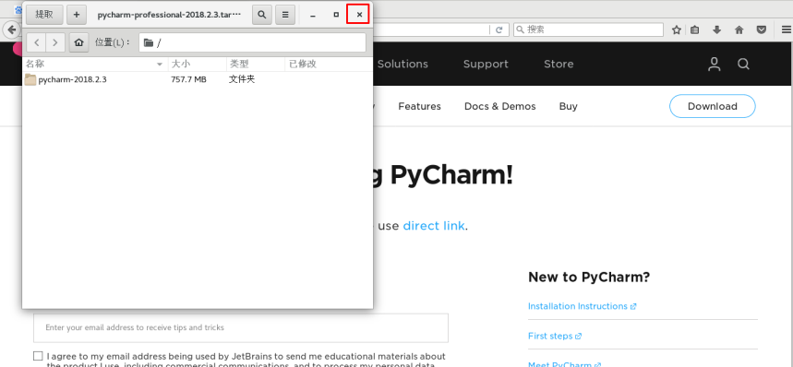

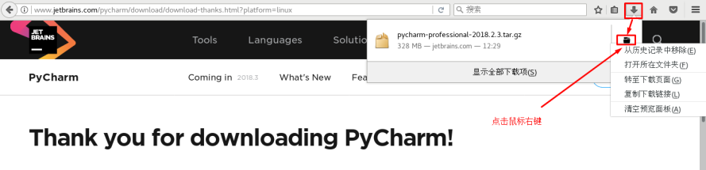

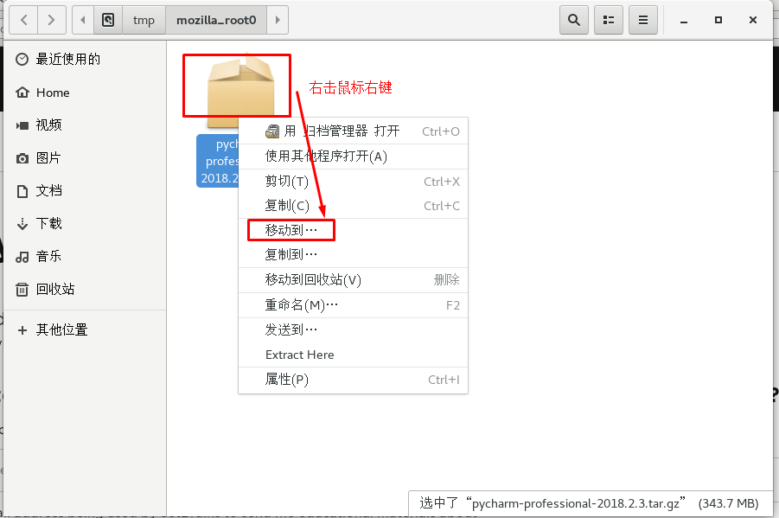

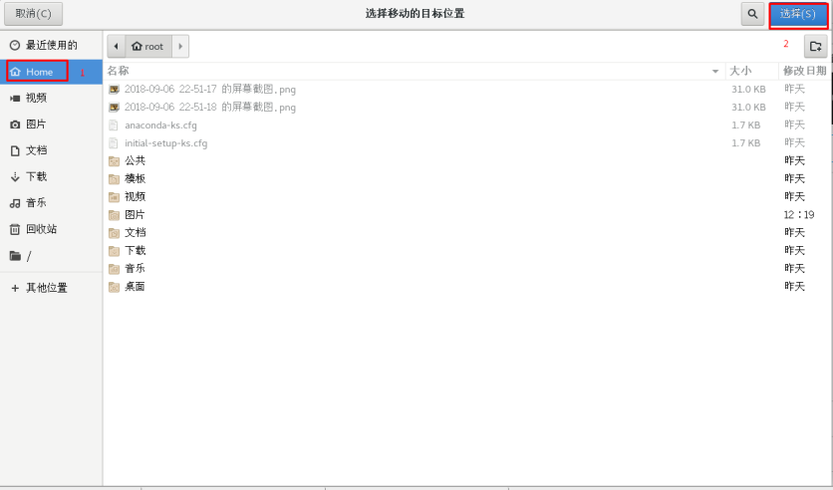

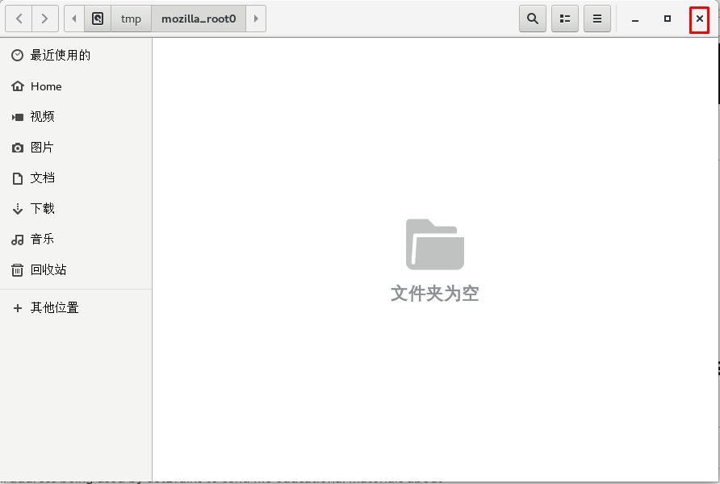

文件已经被移动至/root目录中

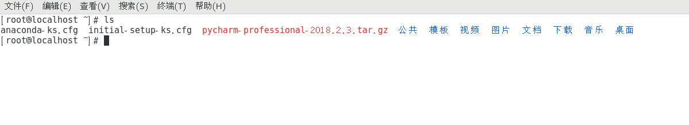

**[**root**@**localhost **~]**# cd pycharm-2018.2.3**/**

**[**root**@**localhost pycharm-2018.2.3**]**# ls

bin

**[**root**@**localhost pycharm-2018.2.3**]**# cd bin

**[**root**@**localhost bin**]**# ls

pycharm.sh

3、pycharm安装

**[**root**@**localhost bin**]**# **./**pycharm.sh

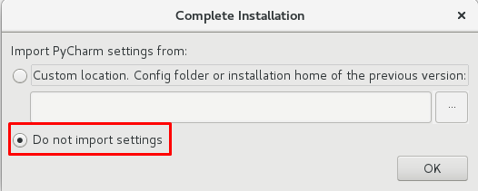

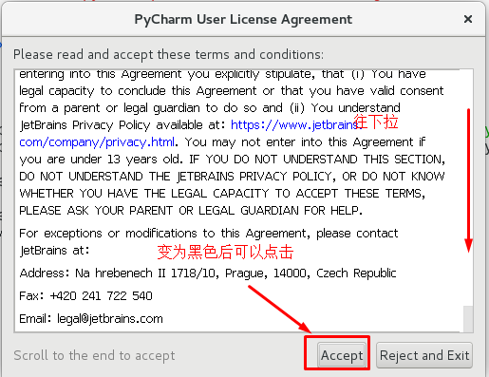

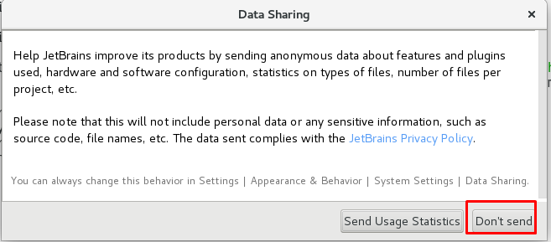

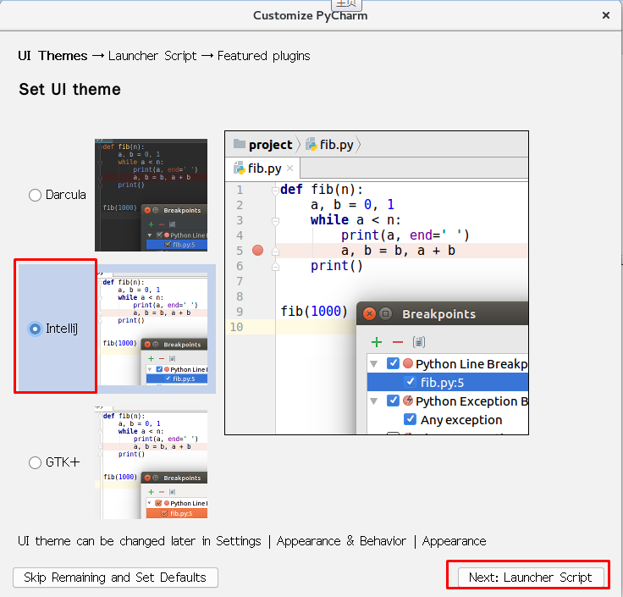

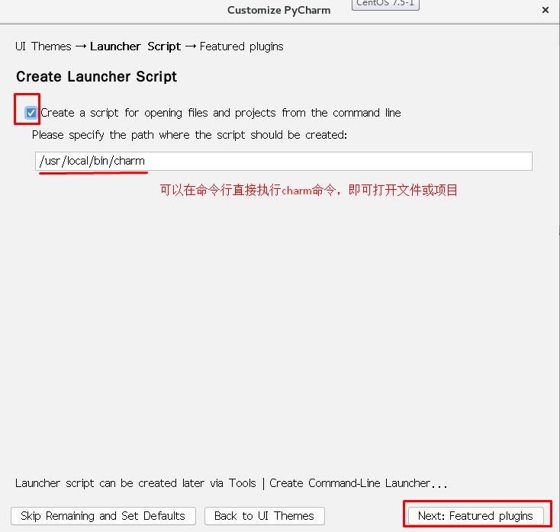

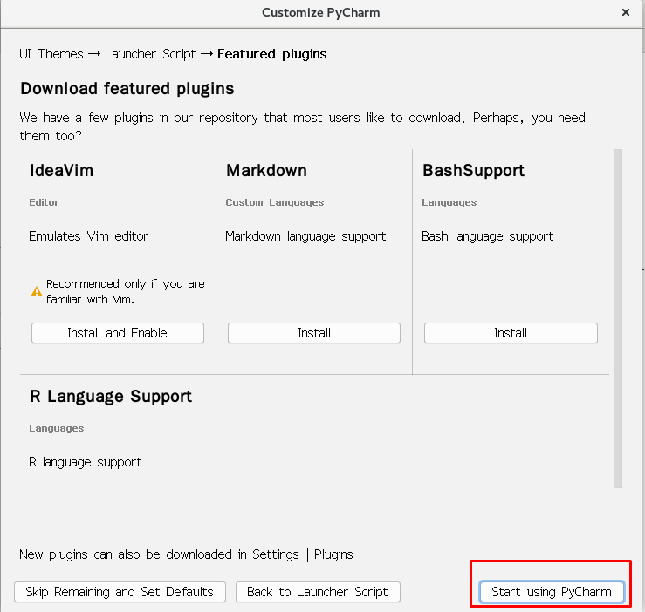

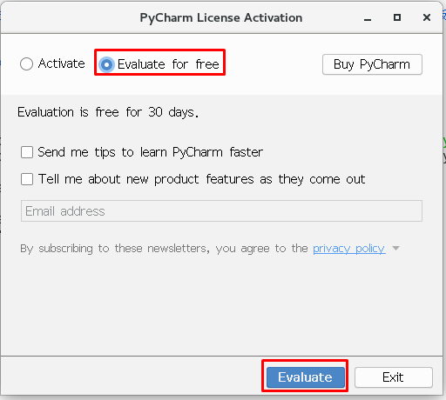

4、pycharm简单使用

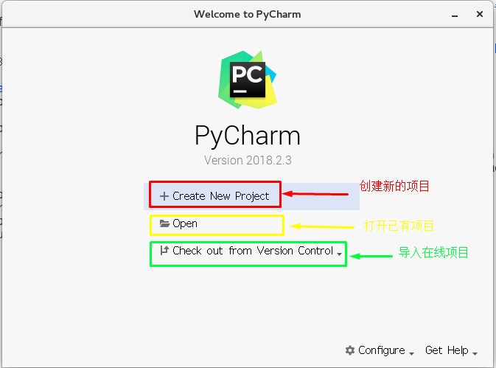

创建新项目：

**[**root**@**localhost **~]**# mkdir **/**root**/**PyProjectOne

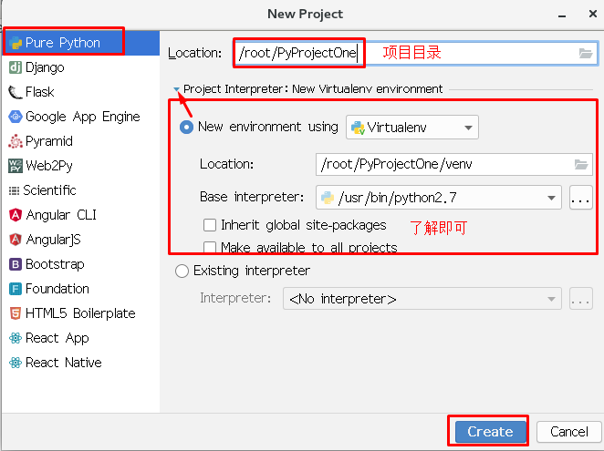

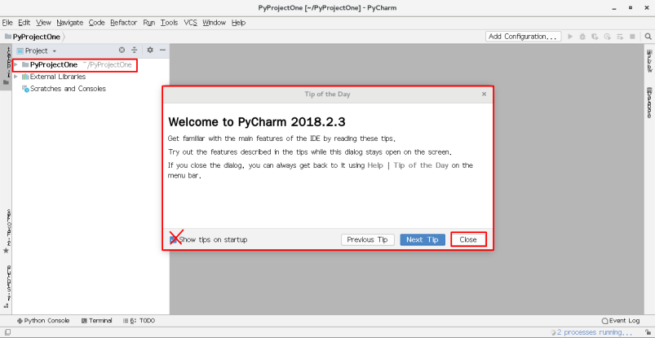

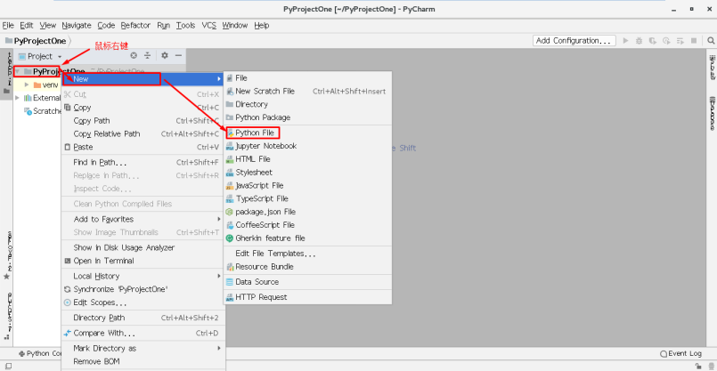

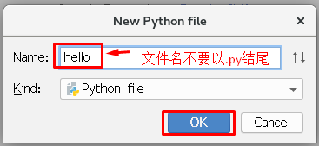

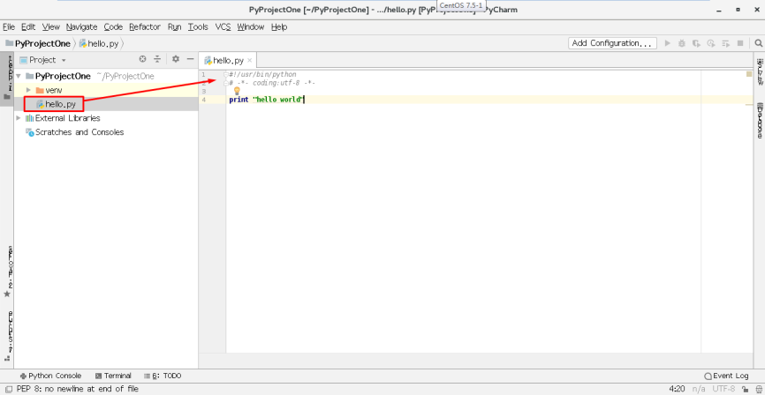

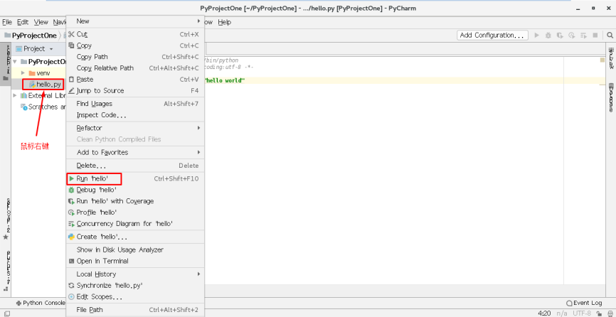

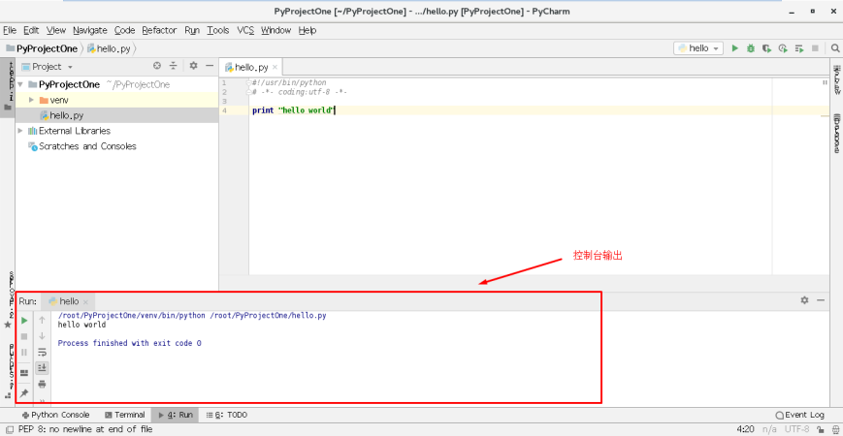

### 五、Centos7.5系统Python多版本开发部署

1、下载pyenv

**[**root**@**localhost **~]**# git clone https://github.com/pyenv/pyenv.git **~/.**pyenv

**[**root**@**localhost **~]**# echo 'export PYENV_ROOT="$HOME/.pyenv"' **>>** **/**etc**/**profile

**[**root**@**localhost **~]**# echo 'export PATH="$PYENV_ROOT/bin:$PATH"' **>>** **/**etc**/**profile

**[**root**@**localhost **~]**# tail **-**2 **/**etc**/**profile

**export** PYENV_ROOT**=**"$HOME/.pyenv"

**export** PATH**=**"$PYENV_ROOT/bin:$PATH"

**[**root**@**localhost **~]**# source **/**etc**/**profile

**[**root**@**localhost **~]**# pyenv version

system **(set** by **/**root**/.**pyenv**/**version**)**

**[**root**@**localhost **~]**# pyenv versions

**\*** system **(set** by **/**root**/.**pyenv**/**version**)**

**[**root**@**localhost **~]**# pyenv install **--**list

2、使用pyenv部署python多版本

**[**root**@**localhost **~]**# yum **-**y install zlib-devel bzip2-devel openssl-devel ncurses-devel sqlite-devel readline-devel tk-devel gdbm-devel libpcap-devel xz-devel

**[**root**@**localhost **~]**# pyenv install 2**.**7**.**15

**[**root**@**localhost **~]**# pyenv install 3**.**6**.**6

**[**root**@**localhost **~]**# pyenv versions

**\*** system **(set** by **/**root**/.**pyenv**/**version**)**

2**.**7**.**15

3**.**6**.**6

3、使用pyenv插件virtualenv插件

**[**root**@**localhost **~]**# git clone https://github.com/pyenv/pyenv-virtualenv.git **$(pyenv root)/**plugins**/**pyenv-virtualenv

**[**root**@**localhost **~]**# echo 'eval "$(pyenv init -)"' **>>** **/**etc**/**profile

**[**root**@**localhost **~]**# echo 'eval "$(pyenv virtualenv-init -)"' **>>** **/**etc**/**profile

**[**root**@**localhost **~]**# tail **-**4 **/**etc**/**profile

**export** PYENV_ROOT**=**"$HOME/.pyenv"

**export** PATH**=**"$PYENV_ROOT/bin:$PATH"

**eval** "$(pyenv init -)"

**eval** "$(pyenv virtualenv-init -)"

**[**root**@**localhost **~]**# source **/**etc**/**profile

**[**root**@**localhost **~]**# pyenv commands

**[**root**@**localhost **~]**# pyenv virtualenv 2**.**7**.**15 env2715

**[**root**@**localhost **~]**# pyenv virtualenv 3**.**6**.**6 env366

**[**root**@**localhost **~]**# pyenv activate env2715

pyenv-virtualenv**:** prompt changing will be removed from future release. configure **`export PYENV_VIRTUALENV_DISABLE_PROMPT=1' to simulate the behavior.**

**(env2715) [root@localhost ~]# pip install ipython**

**(env2715) [root@localhost ~]# ipython**

**Python 2.7.15 (default, Sep 7 2018, 15:28:40)**

**Type "copyright", "credits" or "license" for more information.**

**IPython 5.8.0 -- An enhanced Interactive Python.**

**? -> Introduction and overview of IPython's features.**

**%quickref -> Quick reference.**

**help -> Python's own help system.**

**object? -> Details about 'object', use 'object??' for extra details.**

**In [1]: print("hello world")**

**In [2]: exit**

**(env2715) [root@localhost ~]# pyenv deactivate**

[root@localhost ~]# pyenv activate env366

pyenv-virtualenv: prompt changing will be removed from future release. configure `export PYENV_VIRTUALENV_DISABLE_PROMPT=1' to simulate the behavior.

(env366) [root@localhost ~]# ipython

Python 3.6.6 (default, Sep 7 2018, 15:53:53)

Type 'copyright', 'credits' or 'license' for more information

IPython 6.5.0 -- An enhanced Interactive Python. Type '?' for help.

In [1]: word = "this is a test"

In [2]: exit

(env366) [root@localhost ~]# pyenv deactivate

4、pycharm使用多版本环境

4.1 下载pycharm

http://www.jetbrains.com/pycharm/

4.2 安装pycharm

略

4.3 创建多项目目录

[root@localhost ~]#mkdir w1

[root@localhost ~]#mkdir w2

4.4 pycharm创建多python版本项目

